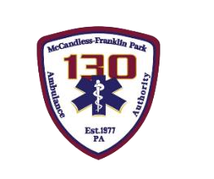

McCandless-Franklin Park Ambulance Authority
Board of Directors Meeting
Monday, June 16, 2025

Login Information (copy and paste into browser):
https://teams.microsoft.com/l/meetup-join/19%3ameeting_MDFlYWJhYmUtMmFmYy00MjViLTkzYjgtNGNmOGEyNDQ0Zjcw%40thread.v2/0?context=%7b%22Tid%22%3a%228f3e4a0a-a8ea-4a0b-a125-60c2622f7152%22%2c%22Oid%22%3a%22919e08f7-0e58-4813-a908-384be49dc2b0%22%7d
- Call To Order

- Pledge of Allegiance
- Public Comment
- Approval of Minutes from Last Meeting
- Presentation of 2024 Audit by James Hune from Herbein

Human Resources
-Personnel Updates -TEAM Meeting

7. Operations Report
-KPI Report -Operations Summary -CQI Report/AHA Commendation
-Medic 132 Repairs -Wheelchair Van Operations

8. Financial Report
-Financial Reports: Vote to approve May 2025 Disbursements of $332,132.43
-Financial Reports: Review and discussion of other financial reports

9. Facilities
-Station 2: General Repairs

10. Old Business
-Update: Communications with Municipalities…TOM Presentation on 6/23
-Update: Highmark Contract
11. New Business
-Vote to Approve the 2024 Audit
-Marketing Plan Discussion and VOTE
12. Executive Session: Personnel

13. Adjournment

Next Board Meeting:
Monday, July 21, 2025
6PM McCandless-Franklin Park Ambulance Authority Headquarters
Vision Statement
MFPAA is the Employer of Choice in establishing new benchmarks toward Clinical Excellence.

