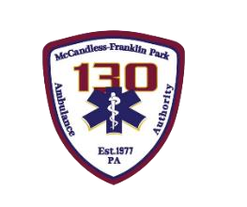

McCandless-Franklin Park Ambulance Authority
Board of Directors Meeting
Monday, July 15, 2024

Login Information (copy and paste into browser):
https://teams.microsoft.com/l/meetup-join/19%3ameeting_MDFlYWJhYmUtMmFmYy00MjViLTkzYjgtNGNmOGEyNDQ0Zjcw%40thread.v2/0?context=%7b%22Tid%22%3a%228f3e4a0a-a8ea-4a0b-a125-60c2622f7152%22%2c%22Oid%22%3a%22919e08f7-0e58-4813-a908-384be49dc2b0%22%7d
- Call To Order

- Pledge of Allegiance
- Public Comment
- Approval of Minutes from Last Meeting

Human Resources
-Personnel Updates

6. Operations Report
-KPI Report -Operations Summary -CQI Report

7. Financial Report
-Financial Reports: Vote on June 2024 Disbursements
-Financial Reports: Review and discussion of other financial reports
-2025 Operating Budget: For Approval
-10 Year Capital Plan: For Approval

8. Facilities

9. Old Business
-Comms w Municipalities

10. New Business
-Annual Audit: Update

11. Adjournment

12. Executive Session

Next Board Meeting:
Monday, August 19, 2024
6PM McCandless-Franklin Park Ambulance Authority Headquarters

Vision Statement
MFPAA is the Employer of Choice in establishing new benchmarks toward Clinical Excellence.

